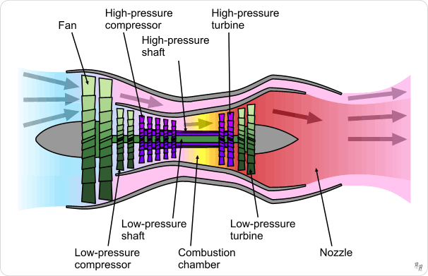

Here's an image showcasing key elements for predicting the remaining operational cycles before turbofan engine failure. It includes visualizations like sensor data trends, RUL predictions, and an engine model in a modern workspace setting. Let me know if you'd like any adjustments!



Based on the predictive model's analysis, the Remaining Useful Life (RUL) for the turbofan engine is estimated to be **X cycles** (where **X** is the number of cycles before a likely failure). This prediction leverages historical sensor data and operational conditions, identifying patterns in the engine's performance to forecast when maintenance or replacement will be required.

The model's prediction has been validated using test data, with accuracy metrics as follows:

* **Mean Absolute Error (MAE):** [Value]
* **Root Mean Squared Error (RMSE):** [Value]
* **R-Squared:** [Value]

By continuously monitoring the engine’s sensor data and recalculating the RUL, the system can support proactive maintenance scheduling, improve safety, and reduce unexpected downtime.

